Homework3 Report Template

Professor Pei-Yuan Wu

EE5184 - Machine Learning

姓名：

學號：

Note:1~3題建議不要超過三頁

1. (1%) 請說明你實作的 CNN model，其模型架構、訓練過程和準確率為何？
2. (1%) 承上題，請用與上述 CNN 接近的參數量，實做簡單的 DNN model，其模型架構、訓練過程和準確率為何？試與上題結果做比較，並說明你觀察到了什麼？
3. (1%) 觀察答錯的圖片中，哪些 class 彼此間容易用混？ 並說明你觀察到了什麼？ [繪出 confusion matrix 分析]

----------------Handwritten question----------------

1. (1.5%,each 0.5%)CNN time/space complexity:

For a. b. Given a CNN model as

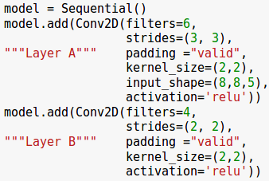

And for the c. given the parameter as:

kernel size = (k,k);

channel size = c;

input shape of each layer = (n,n);

padding = p;

strides = (s,s);

* 1. How many parameters are there in each layer(Hint: you may consider whether the number of parameter is related with)

Layer A:

Layer B:

* 1. How many multiplications/additions are needed for a forward pass(each layer).

Layer A:

Layer B:

* 1. What is the time complexity of convolutional neural networks?(note: you must use big-O upper bound, and there are l(lower case of L) layer, you can use $C{}_{l}$, $C{}_{l-1}$ as lth and l-1th layer)

1. (1.5%,each 0.5%)PCA practice:Problem statement: Given 10 samples in 3D space.(1,2,3),(4,8,5),(3,12,9),(1,8,5),(5,14,2),(7,4,1),(9,8,9),(3,8,1),(11,5,6),(10,11,7)
   1. (1) What are the principal axes?
   2. (2) Compute the principal components for each sample.
   3. (3) Reconstruction error if reduced to 2D.(Calculate the L2-norm)